# Assignment 4 by Zhenyang Lu

**0. What is the total average log return for each trader? What is the average total arithmetic return for all traders?**

0.0 Analysis

To solve this problem, I created a method called simulate_once( ) to simulate one year total average log return for N traders, Which is a parameter for the method, then convert it into arithmetic return. Then, created simulate_many( ) to simulate M consecutive years` log return. Use this method to compute consecutive years` total return.

0.1 Code

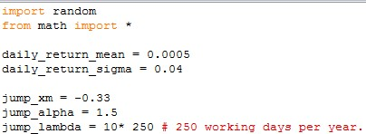

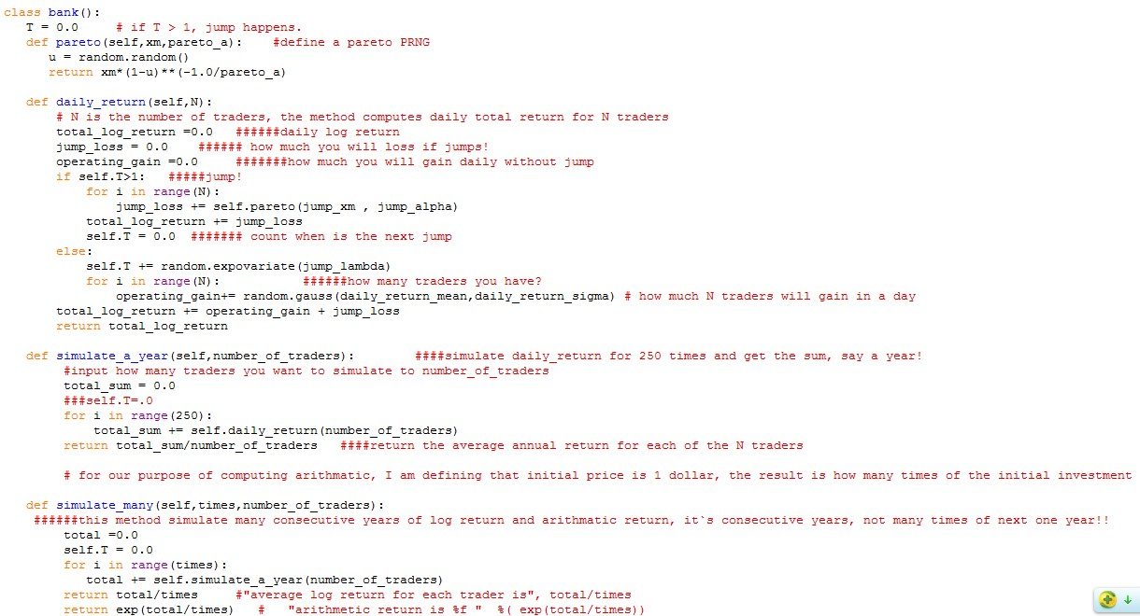

0.2 Result of the first case:

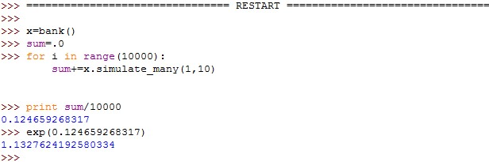

The first number, 0.124659268317, is the average yearly log return for a trader, the second figure,

1.1327624192580334, the arithmetic return. To be convenient, I assume the initial investment at beginning of the first year is $1 dollar. The second number, arithmetic return, means for every dollar you invest, you will get 1.1328 dollar, earning 13.28% profit for each trader. So 0.1247 is the log average total return for each trader and 13.28% is the arithmetic return.

**1. Discuss the similarity between this problem and pricing an option using jump diffusion.**

1.0 When pricing an call option using jump diffusion, if the price of the underlying assets goes far beyond the strike price, your potential gains or losses (depending on you are long or short) of holding the option will go to unlimited (take it to extreme) and if the price of the underlying assets goes far below the strike price your potential gain or loss will be strike price minus asset price. These two cases are the same as the loss when jump happens in this assignment.

**2. Discuss the effects of increasing N, decreasing N, increasing A, decreasing A. In our own self interest, what is the best strategy? In your company interest what is the best strategy?**

2.0 Effects of A and N

If you have **only** one trader, the expected average return is still the same as the case that have many traders. However, the fluctuation of the return is very fierce. Namely, if manager has only one trader, he/she are likely to loss job for the unstable return of the trader, the plot below shows the average return for one trader simulating 500 times, the mean = 0.103939 and std = 0.623893

2.1 Effects of increasing N

To show the effect of increasing N, assume you have 1000 traders, the following plot show the average return for each trader in 1000 traders` case. While the mean is 0.1260 closer to the convergence of 0.13, which is shown in question 0, the standard deviation is only 0.0617, which is significantly lower than the case of only one trader. It`s like running a portfolio, the more trader you get the less volatile your return. However, if you hire more traders, the human resource cost is going to increase. Also, too many traders will cause the company to loss more money once the jump occurs. It`s unlikely to give you too many traders.

2.2 Effects of increasing and decreasing A

Given the previous analysis, we could see that a higher A results in a higher total bonus for the manager. This can be show by the following code:

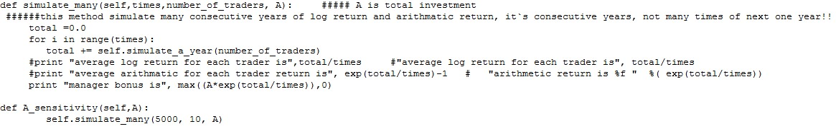

, which hold times of simulation and number of traders to see the change of bonus. We get

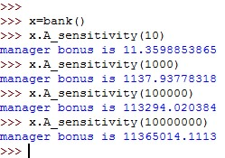

By running the A_sensitivity () method, whose parameter is 10, 1000, 100000 and 1000000. We could see, the more the parameter, the more the manager bonus.

2.3 Best strategy

Regarding A, for the manager and the company, the best strategy is to have as much initial A as possible, if we only consider this in mathematical simulation case. Since this will generate the best and most stable bonus for the manager and best absolute profit for the company. However, for the company, the more money you put, the more absolute profit you earn while the more you loss once jump happens! For the manager, how much money is invested does not affect whether he/she will loss job, since this is only affected by the percent loss, not absolute profit!

Regarding N, I applied portfolio management theory which says the unsystematic risk cannot avoid by holding many stocks( traders) in your portfolio and reorganized my code and use it to simulate how much exactly it is for the best number of trader by testing the average standard deviation of the daily log return for each traders, the standard deviation should go down with the increasing number of traders, when the standard deviation goes stable, which means the standard deviation cannot be pull down by more traders, then at this time, the number of traders is the best strategy. My code is like:

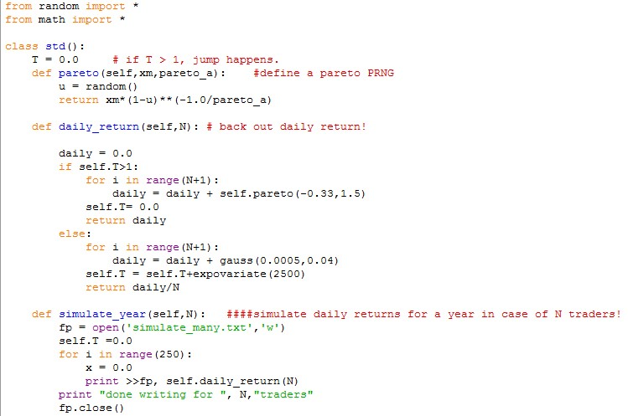

The running result is (non-exhausted) like:

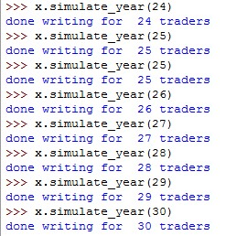

The simulating data has been put into a local .txt file. I put the data into excel and computed the standard deviation, and the result shows the best number of traders is around 25-30, since at those numbers the standard variance changes not too many and stays stable. The excel data is like (non-exhausted due to large amount of data and there are 30 rows and 252 columns in total):

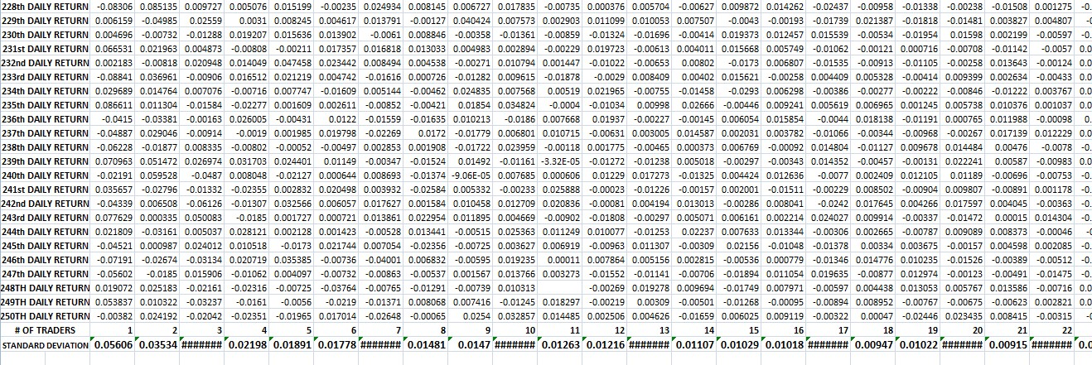

From the following plot, we could see that when the number of traders is about 25-30, the standard variance is stable, which means even if you put more traders, the average risk for each trader is the same, so you do not have to have more traders

This accords to the modern portfolio theory that the more number of stocks (number of traders in this case) in your portfolio, the less portfolio standard deviation is, when it goes within a certain range, the standard deviation is stable, leaving only systematic risk.

So the manager should pick 25-30 traders.